Gaming-Bets

Version 1.0

Revision History

|  |  |  |  |
| --- | --- | --- | --- |
| **Date** | **Version** | **Description** | **Author** |
| 22.12.2015 | 1.0 | Basic Information | André Helbig |

Table of Contents

1. Use-Case Name 4

1.1 Brief Description 4

2. Flow of Events 4

2.1 Basic Flow 4

2.2 Alternative Flows 5

2.2.1 Cannot get Ticket from server 5

3 Special Requirements 5

4 Preconditions 5

4.1 App started 5

4.2 Internet Connection 5

5 Postconditions 5

5.1 Notification if answer is successfully sent 5

6 Extension Points 5

# Use-Case Name

## Brief Description

This Use-Case will allow an admin to answer tickets created by other users.

# Flow of Events

# Basic Flow

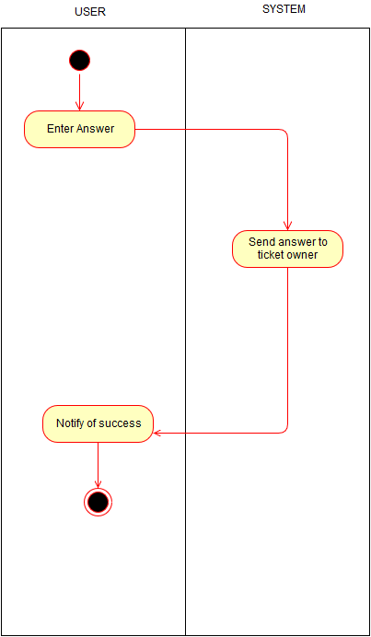

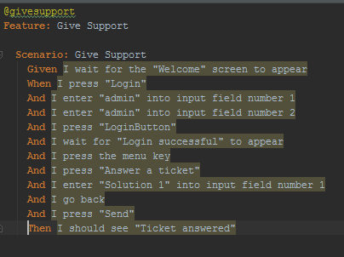

## Alternative Flows

### Cannot get Ticket from server

If the Ticket cannot be fetched from the server the user will be notified of the problem and will have to try again later.

# Special Requirements

n/a

# Preconditions

## App started

The app must be running.

## Internet Connection

To submit feedback or a message, an internet connection is necessary.

# Postconditions

## Notification if answer is successfully sent

As soon as the answer reached the server, a notification will be send to the user.

# Extension Points

n/a